Following on from Hello World from your previous practical...

Part 1

Some special characters
- A newline (line feed) character ('\n')
- A Tab delimiter (‘\t’)
Exercises :
Modify the code to output the following text:
1.
Hello world ! I am alive.

2.
Hello world! I am alive.
I can write on two lines!

3.
Hello world! I am alive.
I can write on two lines!

4.
Happy Christmas
*
***
*****
*******
*********

First Witch When shall we three meet again?
In thunder, lightning, or in rain?
Second Witch When the hurlyburly's done,
When the battle's lost and won.
Third Witch That will be ere the set of sun.

5. Using the tab delimiter \t

Part 2

Java has many built in String methods (actions that can be performed on the String). Once a string is declared, for instance like this …

String yourName;
yourName = “Claire Marie”;

you can then access methods that can be carried out on the String …

Using the dot operator directly after the variable identifier (in this case yourName) in Eclipse will enable you to view the associated methods (Auto completion popup).

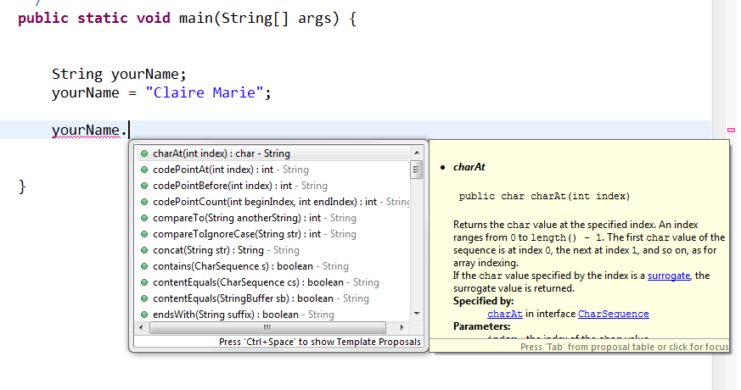

Write a Java program that declares a String. Assign your own name to the String. Then output to screen the following information and perform the following operations on the string:

- Print out the string
- Print out the number of characters in the string
- Print out the first and second characters in the string
- Print out the string with the lowercase characters replaced by uppercase characters
- Print out the string with all occurrences of the letter ‘a’ replaced by ‘%’ (if you don’t have an ‘a’ in your name then use a difference letter).
- Print out the position within the string of the first and last occurrences of the character ‘n’.

For example if the input string is: Aidan McGowan
Then the output should be:
The input String : Aidan McGowan
The number of characters in the string : 13
The first character in the string is A and the second character in the string is n
The string in uppercase : AIDAN MCGOWAN
The string with the letter a replaced with % is : %id%n McGow%n
The character ‘n’ first occurs in position 4

A good reference point for all Java classes is :
http://docs.oracle.com/javase/8/docs/api/index.html
Part 3
Primitive types – remember there are 8 types in Java

int

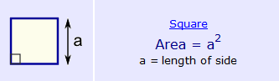

  - Write a Java program that will declare the length of a side of a square as an int and calculate and print out the area. Set the length to 6.

double

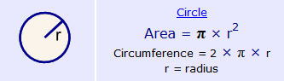

  - Write a Java program that will declare the radius of a circle as a double and calculate and print out the area (to two decimal points). Hint use System.out.printf()… consider PI to be 3.142. Set the radius to 9.

IF statement

  - Write a Java program that will declare two int variables. Use the variable identifiers number1 and number2. Initialise number1 to 3 and number2 to 10. Use a series of if statements to print to screen the biggest value..

Now change number1 to be 44. Run the program again and check if the biggest
value is identified.

Now change both numbers to be the same. Run the program again does your program recognise this? If not change it to do so.

  - Write a Java program that declares the following variables.
Initialise the yearOfBirth e.g. 1980. Now calculate the three other int variables based on the yearOfBirth value.

e.g. yearWhenITurn21 = yearOfBirth + 21
Output should look something like this …
